

**COMSATS University Islamabad**

**Abbottabad, Pakistan**

**VideoVigil**

***By***

**Mubashir Ahmed CIIT/FA20-BSE-063/ATD**

**Nabeel Ahmad CIIT/FA20-BSE-170/ATD**

**Ghulam Abbas CIIT/FA20-BSE-053/ATD**

***Supervisor*Ma’am Neeli Khan**

***Bachelor of Science in Software Engineering (2020-2024)***

**The candidate confirms that the work submitted is their own and appropriate  
 credit has been given where reference has been made to the work of others**.



**COMSATS University, Islamabad Pakistan**

**VideoVigil**

**A project presented to**

**COMSATS Institute of Information Technology, Islamabad**

**In partial fulfillment**

**of the requirement for the degree of**

***Bachelor of Science in Software Engineering (2020-2024)***

**By**

**Mubashir Ahmed CIIT/FA20-BSE-063/ATD**

**Nabeel Ahmad CIIT/FA20-BSE-170/ATD**

**Ghulam Abbas CIIT/FA20-BSE-053/ATD**

**DECLARATION**

We hereby declare that this software, neither whole nor as a part has been copied out from any source. It is further declared that we have developed this software and accompanied report entirely on the basis of our personal efforts. If any part of this project is proved to be copied out from any source or found to be reproduction of some other. We will stand by the consequences. No Portion of the work presented has been submitted of any application for any other degree or qualification of this or any other university or institute of learning.

Mubashir Ahmed Nabeel Ahmad Ghulam Abbas

--------------------------- --------------------------- ---------------------------

**CERTIFICATE OF APPROVAL**

It is to certify that the final year project of BS (SE) “VideoVigil” was developed by   
**Mubashir Ahmed (CIIT/FA20-BSE-063)**, **Nabeel Ahmad (CIIT/FA20-BSE-170)** and **Ghulam Abbas (CIIT/FA20-BSE-053)** under the supervision of “Mam Neeli Khan” and that in her opinion; it is fully adequate, in scope and quality for the degree of Bachelors of Science in Computer Sciences.

---------------------------------------

**Supervisor**

---------------------------------------

**External Examiner**

---------------------------------------

**Head of Department**

**(Department of Computer Science)**

**EXECUTIVE SUMMARY**

VideoVigil is a pioneering project aimed at enhancing online safety and safeguarding mental well-being by developing a specialized web browser extension to detect violent content within online videos. With a focus on real-time video analysis and violence detection, VideoVigil utilizes cutting-edge deep learning models to proactively identify and warn users about potentially distressing content.

The project's foundation lies in successfully implementing a real-time human detection module using the Faster YOLO model, establishing a robust framework for the subsequent development phases. VideoVigil adopts a procedural design methodology, leveraging an iterative and incremental process model to ensure adaptability and continuous improvement throughout development.

Recognizing the severe consequences of exposure to graphic violence, particularly on vulnerable demographics like children and adolescents, VideoVigil integrates seamlessly into web browsers, actively scanning videos across various platforms. Unlike traditional content moderation tools reliant on manual reporting or basic keyword-based algorithms, VideoVigil stands out for its innovative approach to automated violence detection.

Moreover, VideoVigil addresses inherent challenges in deep learning model development, such as computational expense and biases, by striving to create an efficient, trainable, and deployable model while meticulously curating datasets to minimize biases. By doing so, VideoVigil not only contributes to advancing online safety but also raises awareness about the dangers of online violence and promotes responsible internet usage.

The project offers valuable opportunities for learning and skill development in deep learning model creation, dataset curation, and browser extension development, making it a significant endeavor in the current digital landscape. VideoVigil's commitment to efficiency, effectiveness, and responsibility underscores its potential to make a tangible difference in mitigating users' exposure to harmful online content.

In conclusion, VideoVigil represents a groundbreaking initiative poised to revolutionize online safety measures, providing users with a proactive defense against violent content while fostering a culture of responsible internet usage.

**ACKNOWLEDGEMENT**

All praise is to Almighty Allah who bestowed upon us a minute portion of His boundless knowledge by virtue of which we were able to accomplish this challenging task.

We are greatly indebted to our project supervisor “Mam Neeli Khan”. Without her personal supervision, advice and valuable guidance, completion of this project would have been doubtful. We are deeply indebted to them for their encouragement and continual help during this work.

And we are also thankful to our parents and family who have been a constant source of encouragement for us and brought us the values of honesty & hard work.

Mubashir Ahmed Nabeel Ahmed Ghulam Abbas

--------------------------- --------------------------- ---------------------------

**ABBREVIATIONS**

|  |  |
| --- | --- |
| **SRS** | Software Require Specification |
| **SDD** | Personal Computer |
| **VS CODE** | Visual Studio Code |
| **TPU** | Tensor Processing Unit |
| **ML** | Machine Learning |
| **DL** | Deep Learning |
| **CNN** | Convolutional Neural Network |
| **R-CNN** | Region-based Convolutional Neural Network |
| **NLP** | Natural Language Processing |
| **DNN** | Deep Neural Network |
| **SQE** | Software Quality Engineering |

**TABLE OF CONTENTS**

**1.** **Introduction** 11

**1.1.** **Brief** 11

**1.2.** **Relevance to Course Modules** 12

**1.3.** **Project Background** 13

**1.4.** **Literature Review** 14

**1.5.** **Analysis from Literature Review (in the context of your project)** 14

**1.6.** **Methodology and Software Lifecycle for This Project** 15

**1.6.1.** **Rationale behind Selected Methodology** 15

**2.** **Problem Definition** 17

**2.1.** **Problem Statement** 17

**2.2.** **Deliverables and Development Requirements** 17

**2.3.** **Current System (if applicable to your project)** 18

**3.** **Requirement Analysis** 19

**3.1.** **Use Cases Diagram(s)** 20

20

**3.2.** **Detailed Use Case** 20

**3.3.** **Functional Requirements** 21

**3.4.** **Non-Functional Requirements** 21

**Usability** **Error! Bookmark not defined.**

**Performance** **Error! Bookmark not defined.**

**Scalibility** **Error! Bookmark not defined.**

**4.** **Design and Architecture** 22

**4.1.** **System Architecture** 22

**4.2.** **Data Representation [Diagram + Description]** 22

**4.3.** **Process Flow/Representation** 22

**4.4.** **Design Models [along with descriptions]** 22

**References** 23

**LIST OF FIGURES**

Fig 1.1 Block Diagram 8

Fig 2.1 Use Case Diagram 9

**LIST OF TABLES**

Table 1.1 Table1 8

Table 2.1 Table 2 9

1. **Introduction**

This chapter serves as an introductory overview of the Video Vigil project. It outlines the key objectives and scope of the project, emphasizing the significance of developing a specialized web browser extension for detecting violent content within online videos. By offering a summary at the beginning of each chapter, readers gain insights into the content covered, facilitating a structured understanding of the project's progression and findings. Through this introductory chapter, readers are acquainted with the project's aim to enhance online safety and mental well-being by leveraging advanced technology and responsible internet practices.

* 1. **Brief**

The VideoVigil project endeavors to address the critical concern of online violence and sensitive content portrayed in videos, posing substantial risks to users' mental well-being. Through the development of a robust deep learning model, the project aims to autonomously detect instances of violence in videos and issue warnings to users, enabling them to make informed decisions about their viewing experiences. Deployed as a web browser extension, this innovative solution offers easy accessibility and enhances online safety for users. Leveraging advanced deep learning technology and meticulously curated datasets, the project tackles challenges such as computational expense and biases. Adopting an iterative and incremental methodology, the project ensures continuous improvement and adaptation to evolving challenges in model development and dataset curation.

I have chosen the Agile software methodology for my project to develop a VideoVigil system that can detect violence in videos. Agile is a software development methodology that emphasizes iterative development, teamwork, and adaptability. It is well-suited for complex projects, such as my own, because it allows for changes to be made quickly and easily.

The outcome of the VideoVigil project is a sophisticated deep learning model deployed as a web browser extension, effectively detecting instances of violence within online videos in real-time and empowering users with timely warnings. By enhancing online safety and content moderation, the project contributes to fostering a safer and more considerate online environment for users.

Utilizing advanced deep learning techniques, including convolutional neural networks (CNNs) and recurrent neural networks (RNNs), the VideoVigil project develops the violence detection model. Tools such as TensorFlow and PyTorch are employed for model training and deployment. Embracing an iterative and incremental methodology, the project facilitates continuous improvement and adaptation to evolving challenges in model development and dataset curation.

Throughout the project, comprehensive discussions revolve around various aspects, including the critical problem of online violence and sensitive content, the proposed solution utilizing advanced deep learning technology, challenges such as computational expense and biases, and proposed solutions focusing on dataset curation and bias mitigation. The project concludes by underscoring its contributions to enhancing online safety and promoting responsible internet usage, emphasizing the value of the developed deep learning model and web browser extension in creating a safer online environment for users.

**Tools and Technologies**

|  |  |  |  |
| --- | --- | --- | --- |
| **Tools**  **And**  **Technologies** | **Tools** | **Version** | **Rationale** |
| MS Visual Studio | 2015 | IDE |
| MS SQL Server/Mangodb | 2015 | DBMS |
| Pycharm | 2020.2 | IDE |
| Jupyter Notebook | 6.0.3 | IDE |
| Figma | CSC 6 | Design Work |
| MS Word | 2015 | Documentation |
| MS Power Point | 2015 | Presentation |
| Canva | 2.0.5 | Mockups Creation |
| **Technology** | **Version** | **Rationale** |
| Python | 6.0 | Programming language |
| Firebase | 2013 | Database |
| TensorFlow | 2.0 | Framework |

* 1. **Relevance to Course Modules**

This system is built upon the foundation set up by many of the course modules we studied throughout the four-year program of BSE. The courses modules that served as the building blocks for the project are:

**Machine Learning and Artificial Intelligence:** VideoVigil relies on machine learning and AI techniques to develop a deep learning model for detecting violence in videos. This involves implementing algorithms such as CNNs and RNNs, concepts extensively covered in machine learning and AI courses.

**Data Science**: Data science concepts are essential for processing and analyzing large datasets in VideoVigil. Techniques learned in data science and data mining courses, such as data preprocessing and feature extraction, are directly applicable to this project.

**Software Engineering**: The Agile methodology chosen for VideoVigil's development reflects principles learned in software engineering courses. The iterative approach of Agile facilitates continuous improvement and adaptability, crucial for developing and refining the project.

**Computer Vision:** VideoVigil utilizes computer vision techniques to analyze video content for violence detection. Concepts studied in computer vision courses, including image processing and object detection, provide the foundation for implementing video analysis algorithms.

**Ethics in Computing**: Considering the sensitive nature of the project, ethical considerations are paramount in VideoVigil's development. Ethical principles discussed in computing ethics courses guide decisions regarding privacy, bias mitigation, and responsible technology use.

**Web Development:** Deploying VideoVigil as a web browser extension involves web development skills acquired in relevant courses. Knowledge of front-end and back-end development, as well as familiarity with web technologies, is crucial for creating an accessible and user-friendly extension.

**Software Project Management:** in this course we studied how to manage time, resources effectively and efficiently. How to make schedule for your project. Planning is also important we studied how to plan the development process and make the best use of available resources. Through this course we learn how to use the available tools for the planning like making Gantt chart on project plan.

* 1. **Project Background**

The VideoVigil project stems from the escalating concern surrounding online violence, particularly its impact on users' mental well-being. Studies reveal that a significant portion of adolescents, approximately 60%, have encountered violence online, leading to adverse effects such as anxiety and depression. Recognizing the efficacy of deep learning models in detecting violence in videos, with reported accuracies as high as 95%, the project seeks to leverage this technology to mitigate the proliferation of harmful content online.

However, several challenges hinder the widespread adoption of deep learning models for violence detection. Primarily, these models often incur substantial computational costs during training and deployment phases. Additionally, biases inherent in the training data can influence model performance, leading to inaccurate or skewed results. To address these challenges, the VideoVigil project aims to develop a deep learning model optimized for efficiency in both training and deployment. Moreover, meticulous curation of the dataset will be undertaken to minimize biases, ensuring the model's reliability and effectiveness in detecting online violence.

By tackling these challenges head-on, VideoVigil endeavors to provide a proactive solution to the pervasive issue of online violence, ultimately contributing to a safer and more secure online environment for users worldwide.

* 1. **Literature Review**

The proliferation of online violence and sensitive content in videos has spurred various initiatives and solutions aimed at mitigating its adverse effects on users' mental well-being. In this literature review, we examine existing trends, research, and products related to online content moderation, particularly focusing on video vigilance applications.

**ChildSafe:**

ChildSafe Video, while an attempt to safeguard children from harmful content, has faced criticism for its perceived ineffectiveness in filtering out violence adequately. To address this weakness, our project proposes enhancing ChildSafe Video by integrating advanced deep learning models. These models will leverage techniques such as video content analysis, motion detection, and audio processing to identify violence more accurately and effectively, thereby providing enhanced protection for young users.

**StreamGuard:**

StreamGuard, a platform primarily reliant on metadata and user reporting, has been criticized for its potential delays in responding to violent content. Our project aims to improve StreamGuard by incorporating real-time video analysis and machine learning algorithms. By leveraging these technologies, StreamGuard can promptly detect and flag violent content as it appears, thereby minimizing exposure to harmful material and enhancing user safety.

**WebSearch Shield:**

WebSearch Shield utilizes traditional rule-based filters for violence detection, which may lead to false positives and false negatives. To address this limitation, our proposed project offers a more sophisticated approach. By employing deep neural networks and natural language processing techniques, we aim to refine violence content filtering in WebSearch Shield. This approach will enhance the accuracy of content moderation, reducing false alarms and ensuring a safer browsing experience for users.

* 1. **Analysis from Literature Review (in the context of your project)**

The systems that are related to this project include the following list mentioned in the table. Most of these systems are web-based tools supporting similar functionalities of agile software development. The proposed solutions mentioned here make our project triumph over these weaknesses.

|  |  |  |
| --- | --- | --- |
| **Application Name** | **Weakness** | **Proposed Project Solution** |
| ChildSafe | - ChildSafe Video has been criticized for not being very effective at filtering out violence. | Our project aims to enhance ChildSafe Video by implementing advanced deep learning models that analyze video content, motion, and audio to identify violence more effectively. |
| StreamGuard | - StreamGuard primarily relies on metadata and user reporting, which can result in delayed responses to violent content. | StreamGuard Our project seeks to improve StreamGuard by incorporating real-time video analysis and machine learning algorithms to detect and flag violence promptly. |
| WebSearch Shield | - WebSearch Shield uses traditional rule-based filters that may produce false positives and false negatives in violence detection. | The proposed project provides a more sophisticated approach, utilizing deep neural networks and natural language processing to refine violence content filtering and reduce false alarms. |

* 1. **Methodology and Software Lifecycle for This Project**

I have chosen the Agile software methodology for my project to develop a VideoVigil system that can detect violence in videos. Agile is a software development methodology that emphasizes iterative development, teamwork, and adaptability. It is well-suited for complex projects, such as my own, because it allows for changes to be made quickly and easily.

1. 6. 1. **Rationale behind Selected Methodology**

Agile projects are divided into short sprints, typically two weeks long. At the end of each sprint, the team delivers a working product that is evaluated by stakeholders. This feedback is then used to improve the product in the next sprint.

It is collaborative. Agile teams are cross-functional and work together closely throughout the development process. This collaboration helps to ensure that everyone is on the same page and that the product meets the needs of all stakeholders.

It is adaptable. Agile projects are designed to be adaptable to change. This is important because the requirements for software projects often change over time. Agile teams can quickly and easily adapt to these changes without sacrificing quality.

* + 1. **Rationale behind Selected Methodology**

The Agile software methodology was chosen for the development of the VideoVigil system due to its emphasis on iterative development, teamwork, and adaptability. This methodology aligns well with the project's complexity, allowing for quick and easy adjustments as needed.

Iterative Approach: Agile projects are structured into short sprints, typically lasting two weeks. At the end of each sprint, a working product is delivered and evaluated by stakeholders. This iterative process enables continuous improvement based on feedback, ensuring the project remains on track and responsive to evolving requirements.

Collaborative Environment: Agile teams are cross-functional, fostering close collaboration throughout the development process. This collaborative approach ensures that all team members are aligned and actively contribute to meeting the project goals. By involving stakeholders in regular feedback loops, Agile promotes transparency and stakeholder engagement.

Adaptability to Change: Agile projects are inherently adaptable to changes in requirements, which is crucial for dynamic software projects like VideoVigil. As software requirements often evolve over time, Agile allows teams to respond quickly and effectively to these changes without compromising quality. This flexibility ensures that the final product meets the evolving needs of stakeholders and remains relevant in the rapidly changing digital landscape.

1. **Problem Definition**

Following are the problems regarding VideoVigil that we want to overcome through our system.

4. 1. **Problem Statement**

The browser extension we are developing addresses the critical issue of online violence and sensitive content within videos, which can have severe repercussions on users' mental well-being. Our system's primary objective is to autonomously detect such content and issue warnings to users, empowering them to make informed decisions regarding their video consumption. The motivation behind this project stems from the growing need for enhanced online safety, particularly on internet platforms, where users encounter a multitude of videos daily.

While various content moderation tools exist, a comprehensive solution for automatically identifying and flagging potentially distressing videos is not widely accessible. Many existing systems rely on manual reporting or basic keyword-based algorithms, which leaves room for harmful content to evade detection. Our browser extension stands out by harnessing the power of deep learning to autonomously identify violent content, thereby improving online safety for users. The project's uniqueness lies in its potential deployment as a browser extension, ensuring easy accessibility for a wide user base. The re-implementation of such a system offers an invaluable opportunity for learning. It provides practical experience in developing, training, and deploying deep learning models for real-world applications. Additionally, it fosters proficiency in browser extension development, a highly relevant and sought-after skill in today's digital landscape.

Through this project, we anticipate gaining proficiency in various areas. This includes expertise in deep learning model development, encompassing data preprocessing, model architecture design, and optimization. We also expect to acquire skills in dataset curation and bias mitigation, recognizing the paramount importance of a balanced and unbiased dataset.

* 1. **Deliverables and Development Requirements**

The table 2.2 below shows the deliverables and Development requirement of our system.

|  |  |
| --- | --- |
| **Specification** | **Required** |
| VideoVigil Web Browser Extension | JavaScript,HTML,and CSS |
| Deep Learning Model | Python and deep learning frameworks (e.g., TensorFlow, PyTorch). |
| Integrated Development Environment | Visual Studio |
| Documentation | Microsoft Word, PowerPoint, Star UML |
| Programming Languages | Python ,Javascript,CSS |
| Database |  |

* 1. **Current System (if applicable to your project)**

A brief description of an existing system.

The following figure is a sample figure, Figure 2.1. You are required to follow the same style of numbering and caption for the whole report.



*Figure 2.1: Sample picture*

The following table (Table 2.1) is sample table; you are required to follow the same style of numbering and caption for the whole report.

*Table 2.1: Sample Table*

|  |  |  |
| --- | --- | --- |
| **Header 1** | **Header 2** | **Header 3** |
| Text | Text | Text |
|  |  |  |

The following list style is the sample to consistently follow in the whole report.

* List items 1
* List items 2

1. **Requirement Analysis**

The following parts of Software Requirements Specification (SRS) report should be included in this chapter.

4. 1. **Use Cases Diagram(s)**

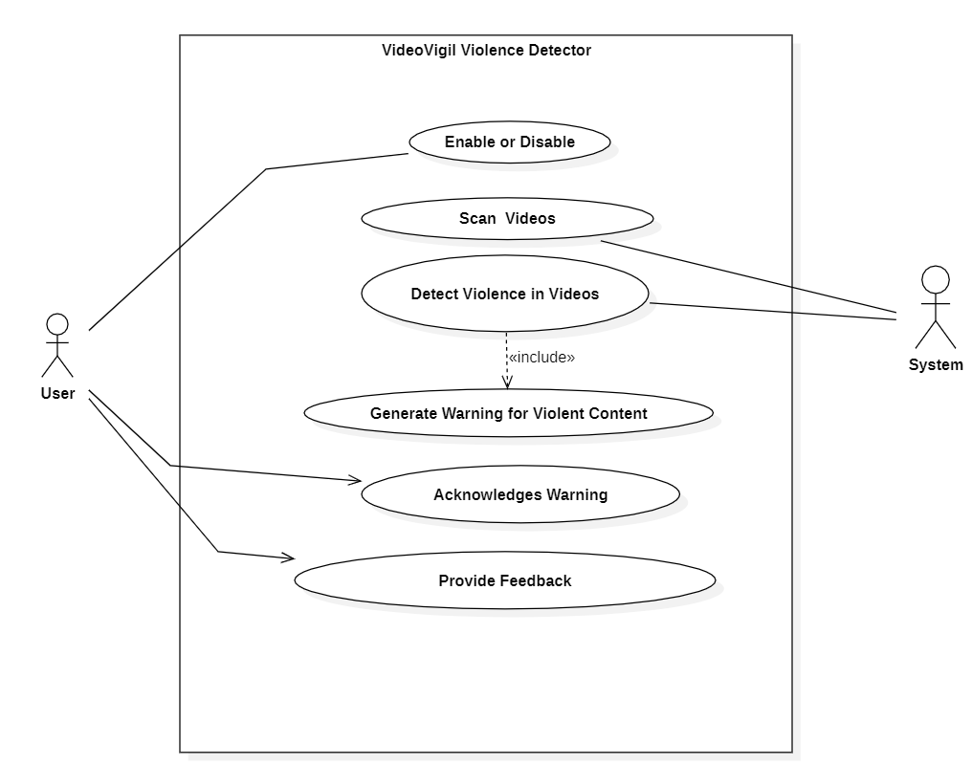

* 1. **Detailed Use Case**

**Storyboards**

****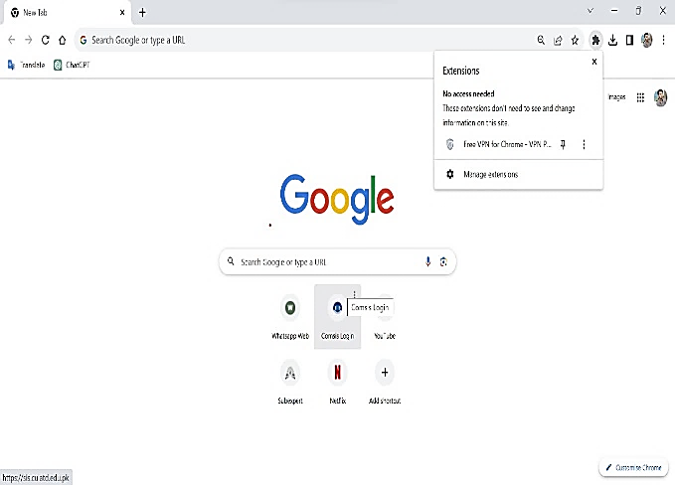

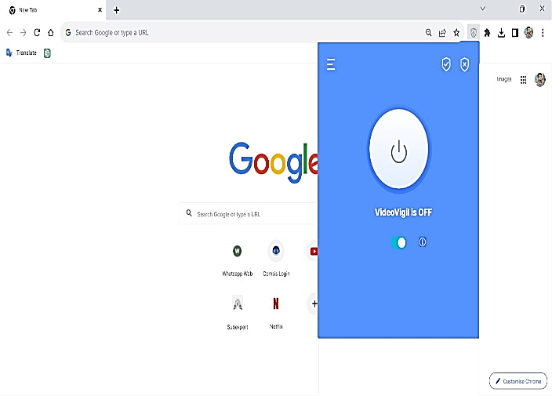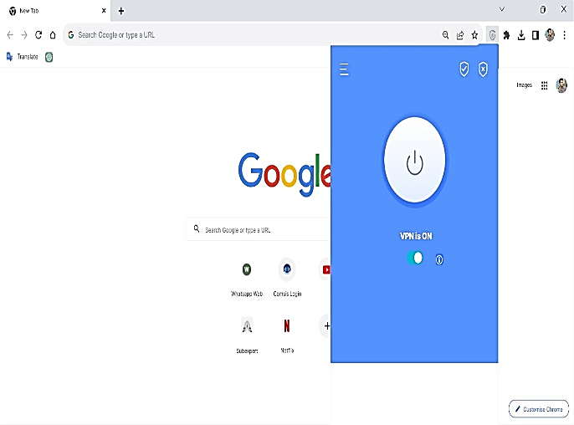

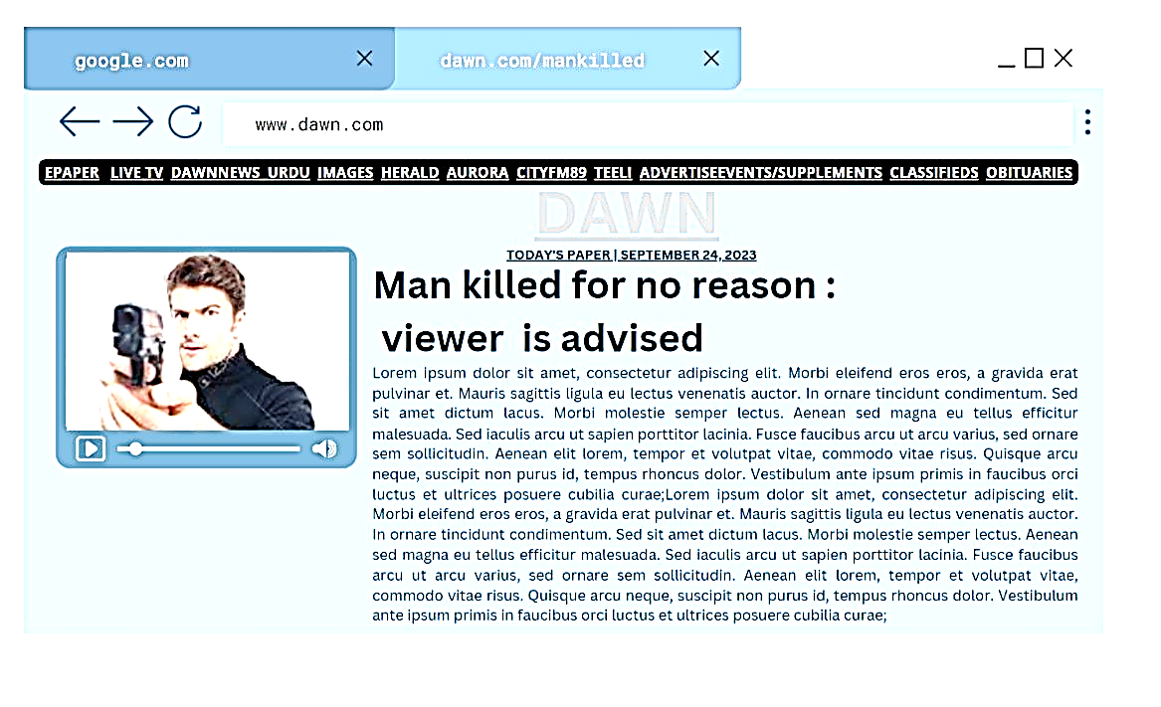

* 1. **Functional Requirements**

**Feature: Video Analysis and Detection**

**FR_1:** The extension shall have the ability to analyze online videos in real-time.

**FR_2:** It shall implement a violence detection mechanism using a deep learning model.

**FR_3:** The initial human detection module, utilizing Faster YOLO, must seamlessly integrate with the violence detection process.

**Feature: Warning Message Generation**

**FR_4:** Upon detecting violent content in a video, the extension shall generate warning messages.

**FR_5:** Warning messages should be clear, concise, and informative, advising users about potentially distressing content.

**Feature: Real-Time Processing**

**FR_6:** The extension shall perform video analysis and violence detection in real-time to provide timely warnings to users.

**FR_7:** Real-time processing should be optimized for performance and responsiveness.

Feature: Model Training and Updating

**FR_12:** The extension should support model training to improve the accuracy of violence detection.

**FR_13:** It shall provide a mechanism for updating the trained model with new datasets.

Feature: Privacy and Security

**FR_14:** The extension must prioritize user privacy and adhere to all relevant data protection regulations.

**FR_15:** Video analysis should be conducted locally on the user's device whenever possible to minimize privacy concerns.

**Feature: Responsiveness**

**FR_18:** The extension should be responsive to different video formats and resolutions.

**FR_19:** It should adapt to various online platforms to ensure broad compatibility.

* 1. **Non-Functional Requirements**

**Usability**

USE-1: The VideoVigil web browser extension must feature a user-friendly interface, ensuring ease of navigation and comprehension, particularly for users with limited technical expertise.

USE-2: Clear and concise instructions for each feature must be provided within the extension, ensuring an intuitive user experience, and enabling users to perform tasks effortlessly while accessing information.

USE-3: VideoVigil must prioritize accessibility, ensuring users with visual impairments, hearing impairments, and mobility impairments can interact effectively with the web browser extension.

**Performance**

PER-1: VideoVigil must be optimized for swift loading and execution, ensuring a seamless user experience.

PER-2: The extension must handle a high volume of requests efficiently, preventing significant delays even during peak usage periods.

PER-3: VideoVigil should efficiently handle large datasets, such as video libraries, for robust performance in video scanning and analysis.

**Scalability**

SCA-1: VideoVigil must be scalable to support a large user base, handling a significant number of requests without compromising performance.

SCA-2: The extension must efficiently handle large datasets, ensuring optimal loading and processing capabilities for videos sourced from memory or a network.

1. **Design and Architecture**

The following parts of Software Design Description (SDD) report should be included in this chapter.

8. 1. **System Architecture**

**Not valid**

* 1. **Data Representation [Diagram + Description]**
  2. **Process Flow/Representation**

**Available file**

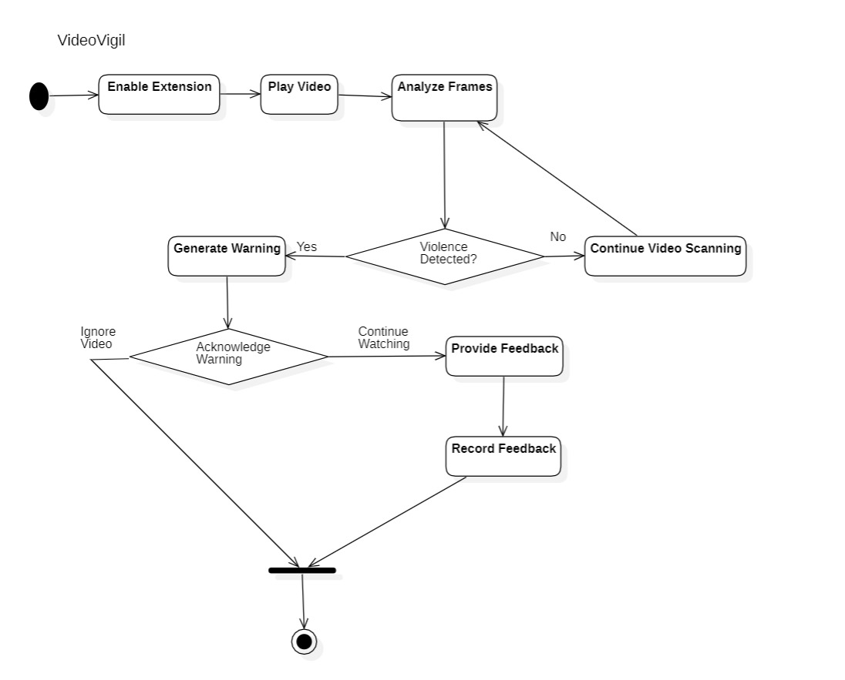

* 1. **Design Models [along with descriptions]**

**Not va;**

**References**

References to any book, journal paper or website should properly be acknowledged. Please consistently follow the style. The following are few examples of different resources i.e. journal article, book, and website.

* 1. Viola, P., & Jones, M. (2001). Rapid Object Detection using a Boosted Cascade of Simple Features. IEEE Computer Society Conference on Computer Vision and Pattern Recognition (CVPR), Vol. 1, pp. 511-518. (Conference paper)
  2. Dalal, N., & Triggs, B. (2005). Histograms of Oriented Gradients for Human Detection. IEEE Computer Society Conference on Computer Vision and Pattern Recognition (CVPR), Vol. 1, pp. 886-893. (Conference paper)
  3. Felzenszwalb, P. F., Girshick, R. B., McAllester, D., & Ramanan, D. (2010). Object Detection with Discriminatively Trained Part-Based Models. IEEE Transactions on Pattern Analysis and Machine Intelligence, 32(9), 1627-1645. (Journal paper)
  4. Dollár, P., Wojek, C., Schiele, B., & Perona, P. (2012). Pedestrian Detection: An Evaluation of the State of the Art. IEEE Transactions on Pattern Analysis and Machine Intelligence, 34(4), 743-761. (Journal paper)